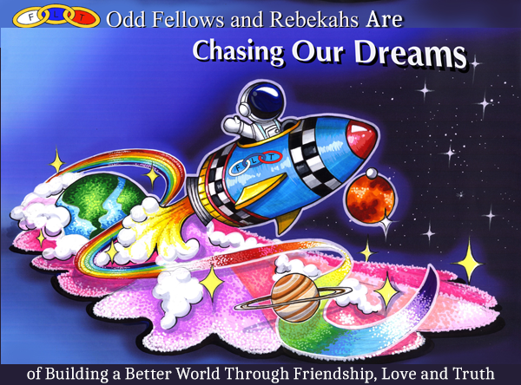***What Are the Odd Fellows and Rebekahs****?*

We are a mutual-benefit society, recognized by the IRS as a 501c(8).

Within a lodge of Odd Fellows, the world is shut out. We are separated from its cares and distinctions, its dissensions and its vices. We meet for mutual counsel, the relief of distress and the elevation of human character. Our laws disallow strife, disco2rd, party and faction, which cause ill will and divisions among humankind. We support each other emotionally, physically and, when necessary, financially through special funding.

We reach outside the lodge to support our neighbors, our communities, and the world. We work together to raise money through various special events or sales to support our projects, special activities and scholarships for students from the local area. The Grand Lodge and Rebekah Assembly of California maintain Rebekah Children’s Services in Gilroy, Senior Citizens Homes in Saratoga and Napa and low-income housing for seniors in Saratoga, and support California Education Foundation, Scholarships, Visual Research Foundation, Arthritis Foundation, Heart Fund, World Hunger and Disaster Assistance, Pilgrimage for Youth, and Living Legacy*.*

***Why Join the Odd Fellows and Rebekahs?***

Enjoy the social aspects of meeting nights, fraternal visits, district meetings, yearly conventions. Reap the benefits of group support: close friendships, and the feeling of satisfaction and joy that comes from working together. Become part of a great organization, doing for others.

For more information, please visit www.ioof.org and www.caioof.org